FORNAX™ ePlanCheck Rule
Rule Information
Rule ID | WTR 3.1.9
Rule Name | Vertical distance of overflow pipes and inlet pipe in the Water Storage Tank
Chapter | 3 Storage
Section | 3.1 General
Handbook | Code of Practice for Water Services  Incorporating Amendment No. 1 and No. 2– CP 48 : 2005

Rule Description
3.1.9 Every inlet pipe to a water storage tank, whether fitted with a float-operated valve or not, shall be fitted in such a position that it discharges at a level higher than the overflowing level of the overflow pipe or, if there is more than one overflow pipe, the highest overflow pipe, by not less than the diameter of that overflow pipe, unless there is an effective means of preventing the siphonage of water through the inlet.

Rule Interpretation
- This rule check for the vertical distance of inlet pipe and the lateral distance between two or more overflow pipe.
- The vertical distance of the inlet pipe should be equal or greater than the internal diameter of overflow pipe.
- Measurement should start at the overflow water level to the inverted level of inlet pipe. (Figure 02)
- If there are more than one overflow pipes at water storage tank, the distance between two shall be equal or greater than the internal diameter of overflow pipe. (Figure 03)
INLET PIPE
SEE FIGURE 02

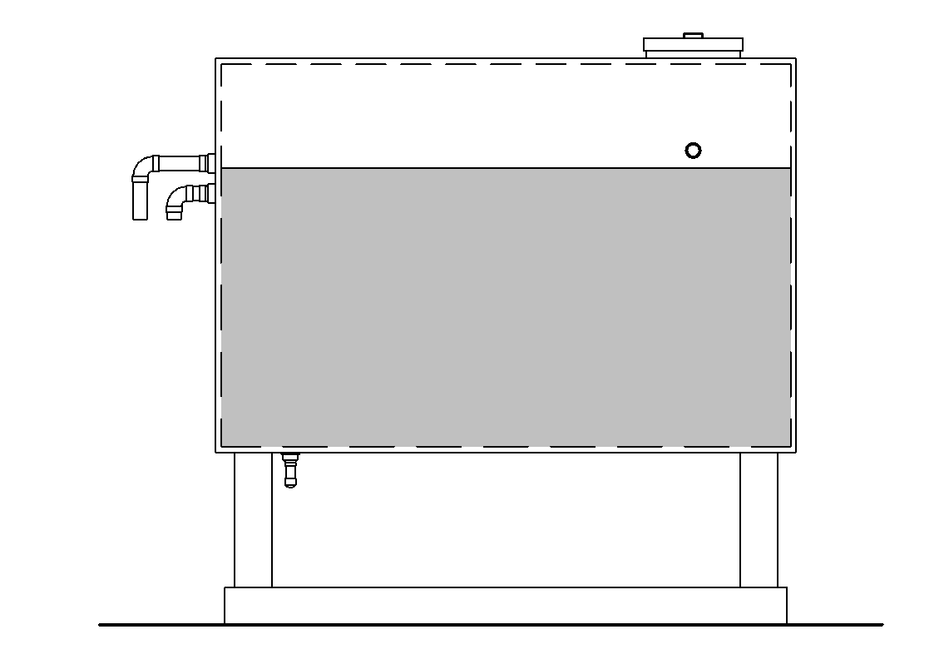
OVERFLOW PIPES
SEE FIGURE 03

WATER STORAGE TANK SECTION
FIGURE 01
OVERFLOW WATER LEVEL


MINIMUM OVERFLOW DIAMETER
INLET PIPE
FIGURE 02
OVERFLOW WATER LEVEL

INLET PIPE

OVERFLOW PIPES

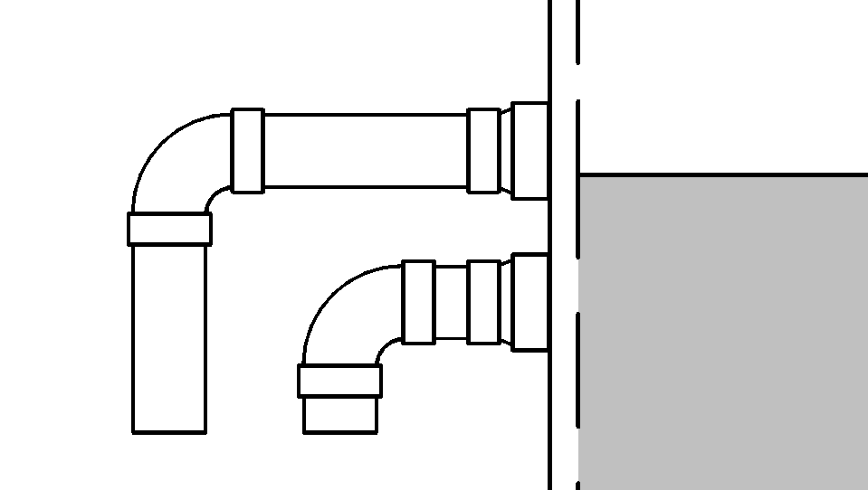
MINIMUM OVERFLOW DIAMETER
OVERFLOW PIPE
FIGURE 03

Rule Scenario

Scenario 01 - Compliant
Requirement | Inlet Pipe should be higher than the overflow pipes at a vertical distance of not less than the diameter of the overflow pipe.  If there are more than one overflow pipe the distance of each pipe should not be less than the diameter of the over flow pipe.
Description | - Overflow Inner Pipe is 75 mm diameter  - Inlet pipe has 80 mm distance from overflow pipe  - Two overflow pipe has 100 mm distance to each other
OVERFLOW WATER LEVEL

VERTICAL DISTANCE 100 mm

OVERFLOW
PIPE
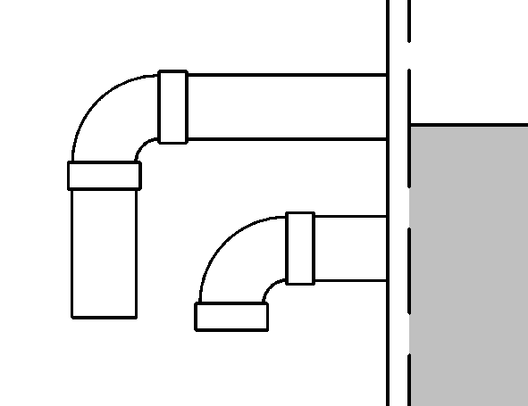
VERTICAL DISTANCE 80 mm
OVERFLOW WATER LEVEL

50 mm DIA. INLET PIPE

INLET PIPE AND OVERFLOW PIPE
FIGURE SCENARIO

Scenario 01 - Non-Compliant
Requirement | Inlet Pipe should be higher than the overflow pipes at a vertical distance of not less than the diameter of the overflow pipe.  - If there are more than one overflow pipe the distance of each pipe should not be less than the diameter of the over flow pipe.
Description | - Overflow Inner Pipe is 75 mm diameter  - Inlet pipe is below the overflow water level  - Two overflow pipe has 50 mm distance to each other.
OVERFLOW WATER LEVEL

OVERFLOW WATER LEVEL

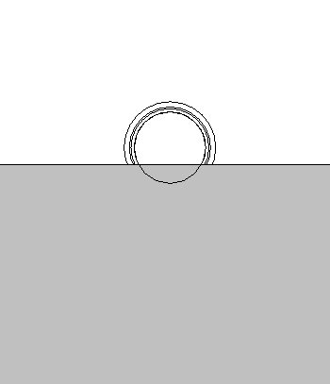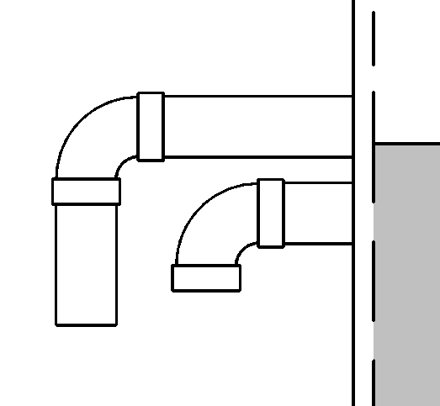
VERTICAL DISTANCE 50 mm

50 mm DIA. INLET PIPE

OVERFLOW PIPE

INLET PIPE AND OVERFLOW PIPE
FIGURE SCENARIO

Request For Information

- The Rule description stated in 24_Appendix 2_COP rules.pdf for WTR 7.1.9 is not found in IBS_PUB-CP 48-2005+Amd 1&2.pdf.

- We believe that the Rule stated in 24_Appendix 2_COP rules.pdf actually directs to WTR 3.1.9 in IBS_PUB-CP 48-2005+Amd 1&2.pdf. Is this correct?

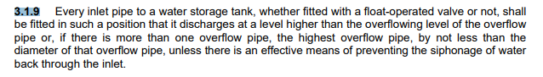

Model PreCheck

Required Elements | Required Attributes
PipeSegment | IfcDescription contains “Inlet Pipe”  IfcDescription contains “Overflow Pipe”
Tank | Any

Rule Parameters

System Type
Cold Water |  | 
Hot Water |  | 
 | Sanitary
 | Sewerage
Vent

Element Type 1
State | Type | Property | Operator | Value
Include | Tank | Any | Contains | N.A.
Exclude |  | Any | Match | N.A.
 |  |  | N.A. | <User defined>

Element Type 2
State | Type | Property | Operator | Value
Include | PipeSegment | IfcDescription | Contains | Inlet Pipe
Exclude |  | Any | Match | N.A.
 |  |  | N.A. | <User defined>

Element Type 3
State | Type | Property | Operator | Value
Include | PipeSegment | IfcDescription | Contains | Overflow Pipe
Exclude |  | Any | Match | N.A.
 |  |  | N.A. | <User defined>

Element Type 1 Condition
Must be found connected with Element Type 2 and Element type 3

Element Type 2 Condition
From the inverted level of Element type 3 the vertical level the pipe must be equal or greater than the diameter of Element type 3

Element Type 3 Condition
If there is more than one Element Type 3 then the distance between pipes must be equal or greater than the diameter of Element Type 3

Result Messages
- 3.1.9 Vertical distance of overflow pipes and inlet pipe on the Water Storage Tank
  - Non-compliant (TotalResultNumeric)
    - BuildingStorey (TotalResultPerFloorNumeric)
      - Element Type 2 Offset = Count; Vertical level is below ElementType3Value Diameter
      - Element Type 3 Distance is below ElementType3Value Diameter
      - No Element Type 2 is found
      - No Element Type 3 is found
  - Compliant (TotalResultNumeric)
    - BuildingStorey (TotalResultPerFloorNumeric)
      - Element Type 2 Vertical Level = Count; Element Type 3 Vertical Distance = Count
- Attention (TotalResultNumeric)
    - BuildingStorey (TotalResultPerFloorNumeric)
      - No ElementType1Value is found

Sample Result Messages
- 3.1.9 Vertical distance of overflow pipes and inlet pipe on the Water Storage Tank
  - Non-compliant (4)
- Level 1 (4)
- Inlet Pipe Offset = 20 mm; Vertical level is below Overflow Pipe Diameter
      - Overflow Pipes Distance is below Overflow Pipe Diameter
      - No Inlet Pipe is found
      - No Overflow Pipe is found
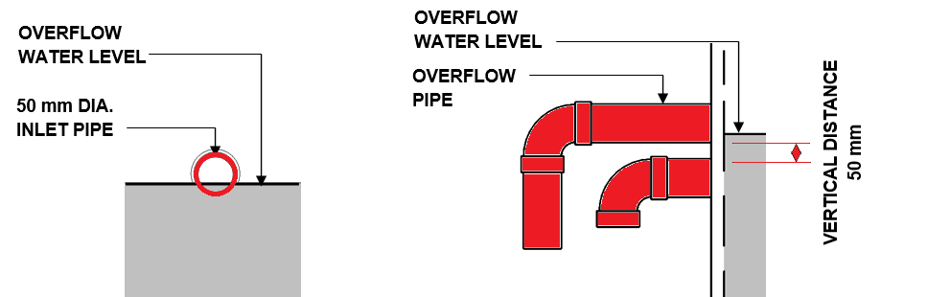

  - Compliant (1)
- Level 1 (1)
      - Inlet Pipe Offset = 80 mm; Overflow Pipe Distance = 100 mm
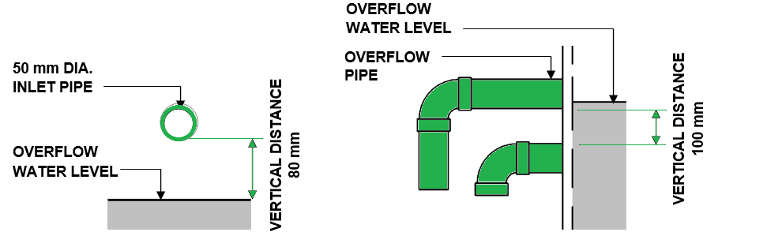

  - Attention (1)
    - 1st Storey (1)
- No Water Storage Tank Found

Sample Result Model Views
- 3.1.9 Vertical distance of overflow pipes and inlet pipe on the Water Storage Tank
  - Non-Compliant
    - Side view.
    - Highlight checked Inlet Pipe.
    - Highlight checked Overflow Pipe.
    - Highlight checked Water Storage Tank.
    - All other elements are translucent except for the checked elements.

  - Compliant
    - Side view.
    - Highlight checked Inlet Pipe.
    - Highlight checked Overflow Pipe.
    - Highlight checked Water Storage Tank.
    - All other elements are translucent except for the checked elements.

Testing Scenario Notes
- Scenario 01 - Compliant
- Level 01
- Water Storage Tank is connected to inlet pipe and has two overflow pipe. The Overflow Inner Pipe is 75 mm diameter. The Inlet pipe has 80 mm distance from overflow water level and the two overflow pipe has 100 mm distance to each other.

- Scenario 01 – Non-Compliant
- Level 01
- Water Storage Tank is connected to inlet pipe and has two overflow pipe. The Overflow Inner Pipe is 75 mm diameter. The Inlet pipe is below the overflow water level and the two overflow pipe has 100 mm distance to each other.

Model:
WTR 7.1.9 Scenario 01 Compliant.ifc
WTR 7.1.9 Scenario 01 Non-Compliant.ifc

Modelling Guideline
- Specify Ifcdescription containing “Inlet Pipe” for relevant PipeSegment.
- Specify Ifcdescription containing “Overflow Pipe” for relevant PipeSegment.

Specification Log
RA | Kawther B. Tabernero
ePC version
Updates | Updating Rule Parameters and Testing

